🧱 Forms of Compound Nouns:
# Source: AI Source: Provided by: [Data Path: Persons Table -> ID Column: 1, Name_En Column: Motasem Essam] -> From: [Chatgpt (GPT-4-turbo)] on [7/26/2025]
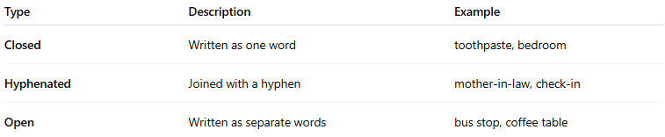
Type | Description | Example
Closed | Written as one word | toothpaste, bedroom
Hyphenated | Joined with a hyphen | mother-in-law, check-in
Open | Written as separate words | bus stop, coffee table

